Experiment: Web API using ASP.NET Core with Swagger
Objective
- To demonstrate Swagger installation in ASP.NET Core Web API.
- To demonstrate Web API listing in the browser using Swagger.
- To demonstrate the usage of GET, POST, PUT, and DELETE action methods.
- To demonstrate the usage of the ProducesResponseType attribute.

Swagger
Swagger is an open-source tool used for documenting and testing RESTful Web APIs. It automatically generates interactive API documentation and allows developers to execute API requests directly from the browser.
Features of Swagger
- Automatically generates API documentation.
- Lists all available API endpoints.
- Supports GET, POST, PUT, and DELETE methods.
- Provides the Try it out option for testing APIs.
- Displays request parameters, response body, and HTTP status codes.

ProducesResponseType Attribute
The ProducesResponseType attribute is used to specify the HTTP status code returned by an action method. It helps Swagger display the possible responses for each API endpoint.
Example:
[ProducesResponseType(StatusCodes.Status200OK)]
[ProducesResponseType(StatusCodes.Status400BadRequest)]

Demonstration
An ASP.NET Core Web API project was created with an EmployeeController. The controller contained GET, POST, PUT, and DELETE action methods. Swagger was used to display all API endpoints. Each action method was executed using the Try it out option, and the responses were successfully returned.

Output
Screenshot 1: Swagger Home Page displaying the EmployeeController.
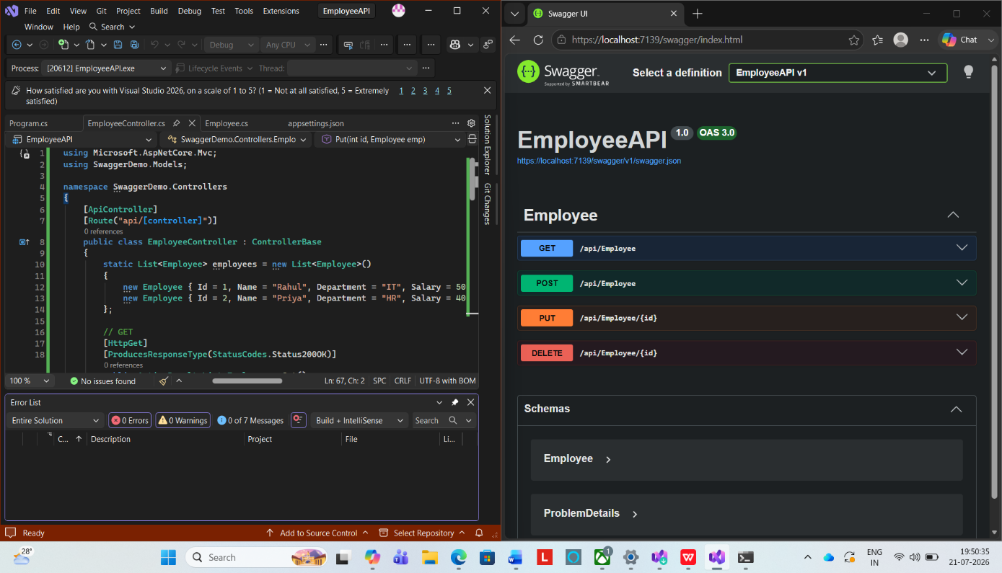

Screenshot 2: GET request executed successfully with 200 OK response.
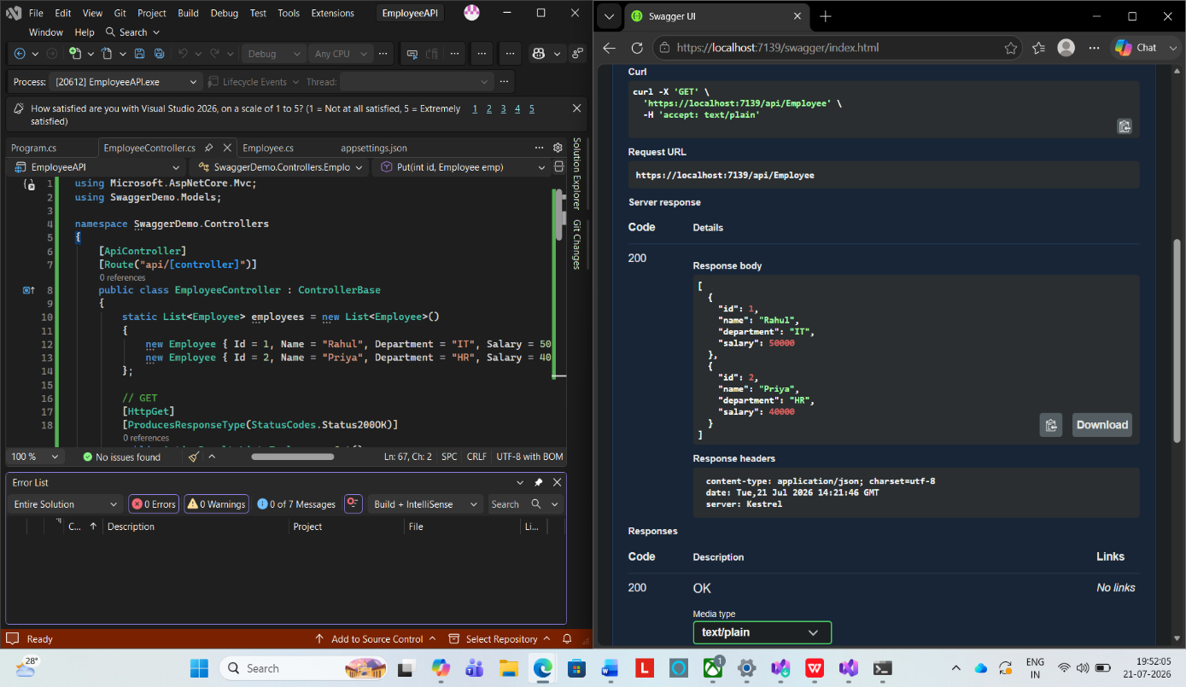

Screenshot 3: POST request execution.
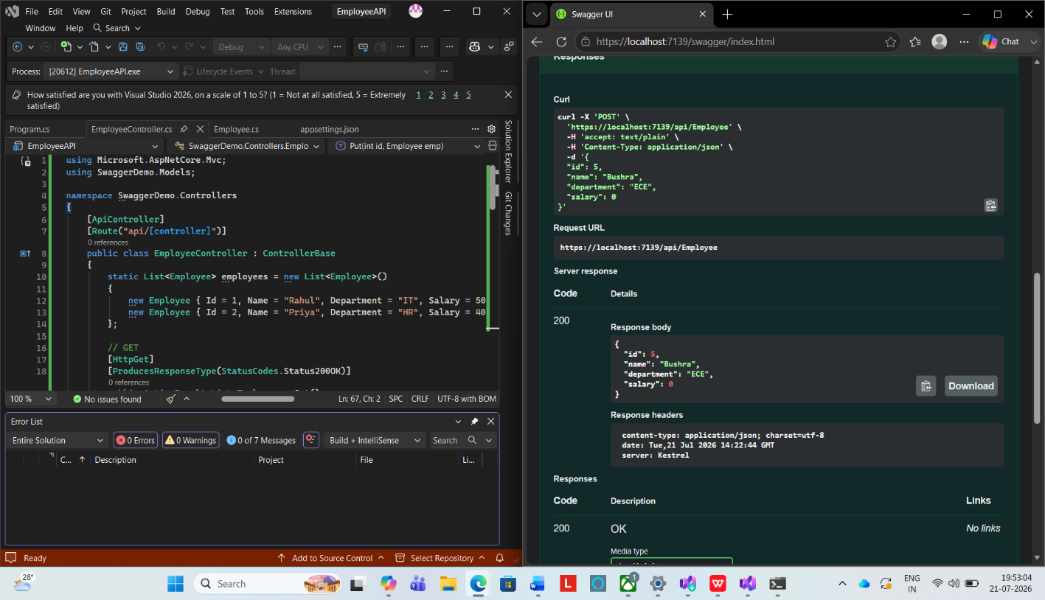

Screenshot 4: PUT request execution.
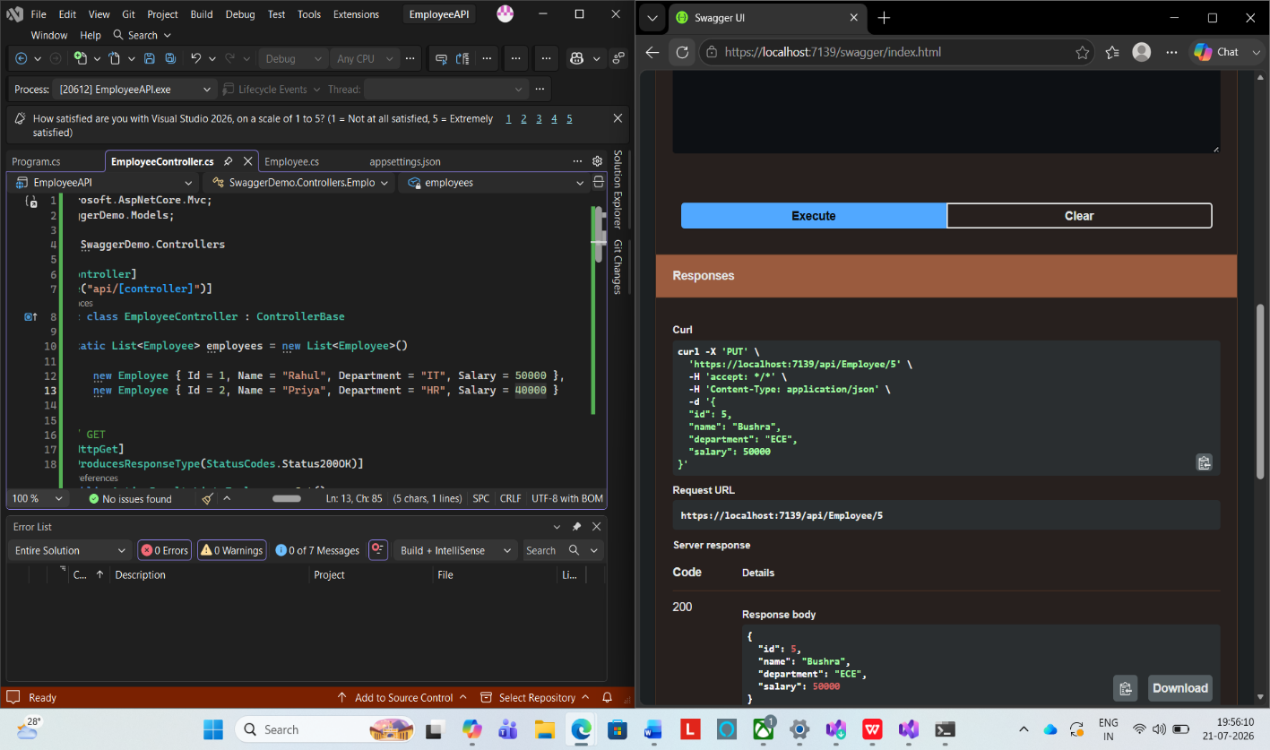

Screenshot 5: DELETE request execution.
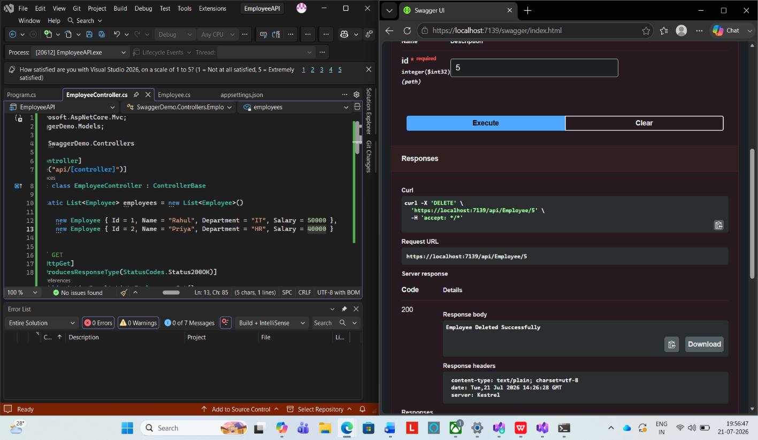

Result
Swagger was successfully used to document and test the ASP.NET Core Web API. The GET, POST, PUT, and DELETE action methods were executed successfully, and the responses were verified using the Swagger interface.

